**Resource Free Section – 18 min 1 min reading time [18 marks]**

|  |  |  |  |
| --- | --- | --- | --- |
| Description: Description: S:\AdminShared\All Staff\1 College Logo's\Baldivis_Logo_colour.jpgName: | \_\_\_\_\_\_\_\_\_\_\_\_\_\_\_\_\_\_\_\_\_\_\_\_\_\_\_\_\_\_\_\_\_\_\_\_\_\_\_\_\_\_\_\_\_\_\_\_\_\_\_ | | Date: *\_\_\_\_\_\_\_\_\_\_\_* |
|  | **Year 11 Applications**  **Test 5, 2019**  **Topics – Univariate Data and Comparing Data** | | 50  = % |
| **Total Time:** | ***55*** *minutes* |  | |
| **Total Reading:** | ***2*** *minutes* |
| **Total Working:** | *53 minutes* |
| **Weighting:** | *6% of the year.* |
| **Equipment:** | *SCSA Formula Sheet; 1 page notes (A4 one side,* ***Unfolded****), CASIO ClassPad; Scientific Calculator* | | |

1. **[3 marks ]**

Circle the correct data type for the following examples:

(i) The number of languages spoken by each person at an airport

A. discrete numerical

B. nominal categorical

C. continuous numerical

D. ordinal categorical

(ii) The shoe size of all year 11s at Baldivis Secondary College

A. discrete numerical

B. nominal categorical

C. continuous numerical

D. ordinal categorical

(v) Everyone at the gym on a Saturday was asked to describe their fitness level as (low, medium or high)

A. discrete numerical

B. nominal categorical

C. continuous numerical

D. ordinal categorical

1. **[3 marks]**

The histogram below shows the weekly rents for a number of households. Comment on the data.

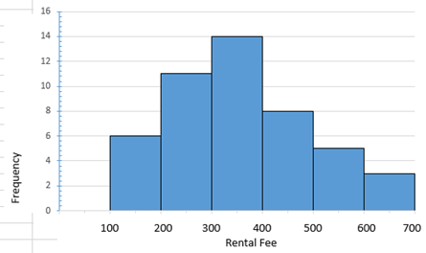

**3. [12 marks: 6, 1, 2, 3]**

The weights of 15 year old boys and girls were recorded to the nearest kilogram and listed below:

BOYS: 55, 75, 92, 48, 60, 74, 58, 84, 44, 74, 50, 56, 82, 49, 58, 69, 72, 64, 46, 62, 81, 48, 53, 78, 54, 68, 60, 52, 66, 56

GIRLS: 53, 39, 66, 40, 58, 70, 50, 38, 63, 60, 42, 36, 74, 72, 56, 66, 37, 43, 72, 64, 43, 44, 61, 49, 56, 53, 48, 53, 50, 38

1. Display the given information using a back-to-back stem and leaf plot
2. How many of these boys and girls were at most 66 kilograms?
3. Which is the most appropriate measure of central tendency that should be used to compare the centres of the data sets? Explain your answer.
4. Write a report (3 sentences) comparing the distribution of weights of these groups?

-End Section 1-

**Resource Section – 35 min 1 min reading time NAME: \_\_\_\_\_\_\_\_\_\_\_\_\_\_\_[32marks]**

1. **[8 marks, 1,1,3,3]**

The following boxplot shows the amount of pocket money ($) 20 children were paid per month.

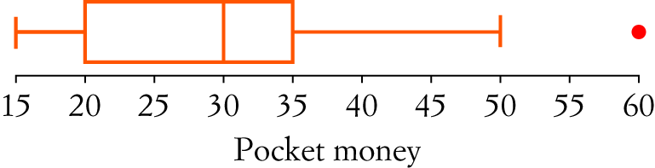

a) What is the median pocket money paid?

b) Complete the sentence:

‘Twenty-five per cent of children had less than \_\_\_\_\_\_\_\_\_\_\_\_\_\_\_of pocket money per month.’

c) How many children were given pocket money of $35 or less?

d) Prove why the data value of $60 is an outlier.

1. **[12 marks: 10, 2]**

The lengths of words in typical definitions in two biology books were counted and found as follows:

**Book 1:**  5, 8, 10, 6, 9, 6, 10, 8, 5, 6, 8, 10, 8, 7, 9, 7, 8, 10

**Book 2:** 12, 8, 5, 24, 7, 9, 5, 5, 22, 5, 13, 9, 10, 9, 5, 17, 14, 8, 14, 7

1. Construct parallel box plots to represent the data on the additional graph paper.
2. Compare, using appropriate summary statistics, the difficulty of the text, assuming that longer words make a text harder to read.
3. **[8 marks: 1, 2, 1, 1, 1, 2]**

This dot plot shows the number of children in each family living on Thredbo Drive.

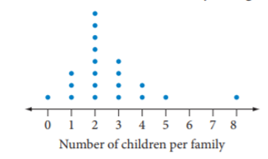

1. How many families live on Thredbo Drive?
2. Calculate the mean number of children per family.
3. What is the outlier?
4. If the outlier is removed from the data set, how is the mean affected?
5. Give a reason why the mean is not a good measure of centre for this data?
6. An extra family moved into Thredbo Drive, increasing the mean number of children to 3. How many children did the new family have?
7. **[4 marks: 2, 2]**

A student went for a run every morning during the month of June along a variety of routes. The time taken for each run was recorded to the nearest minute.

|  |  |
| --- | --- |
| Run time (minutes) | Number of days |
| 16-18 | 2 |
| 19-21 | 4 |
| 22-24 | 5 |
| 25-27 | 10 |
| 28-30 | 4 |
| 31-33 | 3 |
| 34-36 | 2 |

The mean of these 30 times is 25.8 minutes and the standard deviation is 4.6 minutes.

The following month the student continued their morning runs. The 31 times for July are shown in the table below.

|  |  |
| --- | --- |
| Run time (minutes) | Number of days |
| 13-15 | 4 |
| 16-18 | 4 |
| 19-21 | 3 |
| 22-24 | 7 |
| 25-27 | 8 |
| 28-30 | 3 |
| 31-33 | 2 |

1. Find the mean and standard devitaion fpr the month of July
2. In which month were the run times more consistent? Justify your answer with reference to suitable statistics

-End of Section 2-